***CERTIFICATE***

This is to certify that the project entitled, “**OPERA HOUSE OF SYDNEY**" submitted by "**MIRZA HAMZA UMER** " in partial fulfillment of the requirements for the award of "Bachelor In Engineering" in "**Electronics**" at the "Sir Syed University Of Engineering & Technology " is an authentic work carried out by them under my supervision and guidance.

To the best of my knowledge, the matter embodied in the project has not been submitted to any other University / Institute for the award of any Degree or Diploma.

***Dated:  NOVEMBER 14, 2017***

***SIR ADNAN ZAHOOR***

*(Theory Lecturer, SSUET)*

***ACKNOWLEDGEMENT***

The completion of any inter-disciplinary projects depends upon co-operation, co-ordination and combined efforts of several source of knowledge. We are grateful to **SIR ADNAN ZAHOOR**for his even willingness to give us valuable advices and direction whenever we approached him with problems.

I am thankful to him for providing immense guidance for this project.

I am also thankful to **SIR ADNAN ZAHOOR** and **SIR DANISH** for his and her immense guiding , his cooperation and motivation in completing out the project. And also thankful to our best friends..

I also place on record, our senses of gratitude to one and all who directly or indirectly have learnt their hand in this project.

I am making this project not only for marks but to also increase my knowledge.

**MIRZA HAMZA UMER** (Roll No # 2017-EE-079)

Bachelors Of Electronic Engineering,

First Year, Second Semester.

Batch 2017

***CONTENTS***

* ***Chapter # 01***
* ***Preface.***
* ***Chapter # 02***
* ***Executive Summary.***
* ***Chapter # 03***
* ***Introduction of Project.***
* ***Chapter # 04***
* ***Project description.***
* ***Chapter # 05***
* ***Coding of project.***
* ***Chapter # 06***
* ***Instance Diagram.***
* ***Chapter # 07***
* ***Conclusion.***

***CHAPTER #01***

* ***PREFACE***

CAD stands for Computer-Aided Design. Computer Aided Design (CAD) is the latest breakthrough in the modern technology that became a part of variety of professionals like Engineers, Architects and Interior Designers.

CAD helps in the presentation of Engineering Drawings, Architectural Drawings, Interior Designs, Work-flow charts, Organizational Diagrams and Company logos etc.

AutoCAD is a general purpose computer aided drafting application program designed for use on single-user, desktop personal computers and graphic workstations.

An AutoCAD drawing is made up of entities. These can be either simple graphic primitives (such as lines, arcs, circles, text, and so on) or blocks (which are groups of entities). A block is a group of entities that can be manipulated as a single unit. Designs and drawings can be standardized and more accurately presented by using AutoCAD.

Drawings drawn on AutoCAD can also be transmitted to CAM (Computer Aided Manufacturing) system for the actual production of the product design.

An AutoCAD drawing is made up of objects. These can be either simple graphic objects (such as lines, arcs, circles, text, etc.) or blocks (which are groups of objects).

Each object also has certain attributes associated with it, such as line style, text font, or colour.

AutoCAD R14 for windows provides a Graphical user Interface (GUI) similar to that of any other windows package that further simplifies access to commands.

Pull-down menus, dialog boxes, scroll bars and command icons adhere to Windows standards. The open architecture of this product makes it much easier for the developers to create new applications that can run with AutoCAD.

***CHAPTER #02***

* ***EXECUTIVE SUMMARY***

The Sydney Opera House is nominated for the World Heritage List as representing a masterpiece of human creative genius under criterionofthe Operational guidelines Jbr the implementationof the World HeritageConvention. The building fulfils the definition of 'monument' in the World Heritage Convention as an architectural work of outstanding universal value for both art and science. These values are demonstrated in the building's recognition as:

* a masterpiece of late Modern architecture;
* Outstanding achievements in structural engineering and teleological innovation; and
* a world-famous iconic building of the 20thcentury.

TheSydney Opera House has a high level of integrity and authenticity. The physical fabric of the property is in good condition and the impact of deterioration is rigorously controlled by government funded measures. The property continues to be used for its original purpose. The conservation andmanagement of the building is guided by a robust conservation planning framework that uniquely includes a set ofdesignprinciplesbythebuilding'sarchitectJ0mUtzon. The design principles assistinpreservingtheauthenticity and integrity of the buildingasthebuilding evolves, while maintainingisplaceasa worldclassperformance centre.

***CHAPTER #03***

* ***INTRODUCTION OF PROJECT***

The **Sydney Opera House** is a multi-venue [performing arts Centre](https://en.wikipedia.org/wiki/Performing_arts_center) in Sydney, Australia. It is situated on [Bennelong Point](https://en.wikipedia.org/wiki/Bennelong_Point,_New_South_Wales) in [Sydney Harbour](https://en.wikipedia.org/wiki/Port_Jackson), close to the [Sydney Harbour Bridge](https://en.wikipedia.org/wiki/Sydney_Harbour_Bridge), and adjacent to the [Sydney central business district](https://en.wikipedia.org/wiki/Sydney_central_business_district) and the [Royal Botanic Gardens](https://en.wikipedia.org/wiki/Royal_Botanic_Gardens,_Sydney), between [Sydney Cove](https://en.wikipedia.org/wiki/Sydney_Cove) and Farm.

Designed by Danish architect [JørnUtzon](https://en.wikipedia.org/wiki/J%C3%B8rn_Utzon" \o "Jørn Utzon), the building was formally opened on 20 October 1973, by Queen [Elizabeth II](https://en.wikipedia.org/wiki/Elizabeth_II)after a gestation beginning with Utzon's 1957 selection as winner of an international design competition. The [government of New South Wales](https://en.wikipedia.org/wiki/Government_of_New_South_Wales), led by the [premier](https://en.wikipedia.org/wiki/Premier_of_New_South_Wales), [Joseph Cahill](https://en.wikipedia.org/wiki/Joseph_Cahill), authorized work to begin in 1958 with Utzon directing construction. The government's decision to build Utzon's design is often overshadowed by circumstances that followed, including cost and scheduling overruns as well as the architect's ultimate resignation.

Though its name suggests a single venue, the building comprises multiple performance venues which together are among the busiest performing arts centres in the world—hosting over 1,500 performances each year attended by some 1.2 million people. The venues are used for a wide range of performances, produced both in-house and by numerous performing arts companies, including four key resident companies: [Opera Australia](https://en.wikipedia.org/wiki/Opera_Australia), [The Australian Ballet](https://en.wikipedia.org/wiki/The_Australian_Ballet), the [Sydney Theatre Company](https://en.wikipedia.org/wiki/Sydney_Theatre_Company) and the [Sydney Symphony Orchestra](https://en.wikipedia.org/wiki/Sydney_Symphony_Orchestra). As one of the most popular visitor attractions in Australia, more than seven million people visit the site each year, with 300,000 people participating annually in a guided tour of the facility.

The Sydney Opera House is identified as one of the 20th century's most distinctive buildings and one of the most famous performing arts centres in the world, It is managed by the [Sydney Opera House Trust](https://en.wikipedia.org/wiki/Sydney_Opera_House_Trust), under the auspices of the New South Wales Ministry of the Arts.

The Sydney Opera House became a [UNESCO](https://en.wikipedia.org/wiki/UNESCO) [World Heritage Site](https://en.wikipedia.org/wiki/World_Heritage_Site) on 28 June 2007.

***CHAPTER #04***

* ***PROJECT DESCRIPTION***
* ***LINE***
* ***OFFSET***
* ***TRIM***
* ***ARC***
* ***BHATCH***
* ***SNAP***
* ***OBJECT SNAP***
* ***ESCAPE***
* ***UNDO***
* ***REDO***
* ***ERASE***
* ***DIMLINEAR***
* ***DIMRADIUS***
* ***MTEXT***
* ***LINE***

Allows for the sequential drawing of one or more straight lines. Once engaged, this command elicits a prompt of “From point:”, at which point the user specifies a starting point for a line, or they may press RETURN, which starts the line at the end of the previous line or arc that was drawn. Next, the prompt “To point:” is displayed, allowing the user to specify a sequence of points to which the line will extend. They may also type the letter C to close the polygon, or the letter U to undo the previous line segment, or they may simply press RETURN to complete the command

Example:LINE

From point: Enter a point.

To point: Enter a point.

To point: to end line sequence*.*

* ***OFFSET***

 Constructs a new entity parallel to an existing one. This could be a single line, polyline, arc, circle, or curve.

Example:

OFFSET

Offset distance or Through <last>:

Select object to offset:

* ***TRIM***

This command trims parts of certain objects in a drawing in order to finish them precisely at some cutting edge (or edges) that are established by one or more other objects. One or several lines, arcs, circles or polylines must first be identified to serve as cutting edges, which may be selected by any of the methods available. Next, pointing is used to select the parts of the objects that are to be trimmed. Many objects may be selected in this way for trimming, including ones that had been specified as cutting edges.

* ***ARC***

 This command draws arcs, and, like circles, may be dictated in one of several ways. The various methods for constructing arcs with this command are as follows:

(1) specify three different points.

(2) starting point, center, and end point.

(3) starting point, center, and included angle.

(4) starting point, center, and length of chord.

(5) starting point, ending point, and radius.

(5) starting point, ending point, and included angle.

(6) starting point, ending point, and starting direction.

(7) starting point and direction of previous line or arc, plus ending point.

Example:

ARC

Center/<Start point>: Enter a point.

Center/End/<Second point>: Enter a point.

Endpoint: Enter a point.

* ***BHATCH***

A newer command in the AutoCAD quiver, it helps the user to better use the previously discussed Hatch command. It supports boundary hatching, allowing the user to pick a point that is adjacent to the boundary they wanted, and this new command lets AutoCAD search for the nearest entity, then constructs a closed boundary by tracing in a counterclockwise fashion to look for intersection points as well as connecting lines or arcs. Bhatch is convenient in that it allows the user to preview adjustments without having to start over each time.

* ***SNAP***

Sets up a grid that is both invisible and orthogonal, square or rectangular, which all points entered with the mouse may be locked onto.

* ***OBJECT SNAP***

 (Object Snap) In Osnap’s “Running Mode”, it allows points to be precisely located on reference points of existing objects. They may be overridden by selecting different object snap modes for a specific entry.

* ***ESCAPE***

If you want to quickly exit from a dialog box without making any changes, then you can press the ESC key.

* ***UNDO***

 This is like the U command but a bit more complicated. It is able to undo several commands at once, allows the user to set mark points and later undo back to those points, and to group operations together and undo them simultaneously.

* ***REDO***

 This command is used immediately after an error to redo what was undone.

* ***ERASE***

This removes a selected group of entities, which may be entered before or after the command itself is entered.

* ***DIMLINEAR***

Creates a linear dimension with a horizontal, vertical, or rotated dimension line.

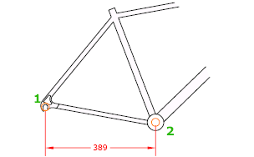

* ***DIMRADIUS***

Measures the radius of a selected circle or arc and displays the dimension text with a radius symbol in front of it. You can use grips to reposition the resulting radius dimension easily.

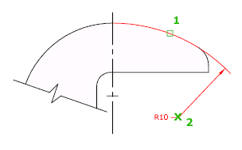

* ***MTEXT***

Displays the In-Place Text Editor, which you can use to edit the dimension text. Use control codes and Unicode character strings to enter special characters or symbols. See [Control Codes and Special Characters](https://knowledge.autodesk.com/support/autocad-for-mac/learn-explore/caas/CloudHelp/cloudhelp/2015/ENU/AutoCAD-MAC-Core/files/GUID-968CBC1D-BA99-4519-ABDD-88419EB2BF92-htm.html).

If alternate units are not turned on in the dimension style, you can display them by entering square brackets ([ ]). For more information about formatting dimension text, see [Select and Modify Objects](http://beehive.autodesk.com/community/service/rest/cloudhelp/resource/cloudhelpchannel/guidcrossbook/jsonp?v=2015&p=ACDMAC&l=ENU&guid=GUID-08A4D2FE-13AD-4D12-943C-75414BDAC1C7).

The current dimension style determines the appearance of the generated measurements.

***CHAPTER #05***

* ***CODING OF PROJECT***

Command: line

Specify first point: <Snap on> 3,

Specify next point or [Undo]: @26<0

Command: offset

Specify offset distance [Through] <Through>: .6

Select object to offset or <exit>:

Specify point on side to offset:

Command: line

Specify first point: line

Specify first point: 29,7.6

Command: line

Specify first point: <Snap off><Snap on> 4,7.5

Specify next point or [Undo]: @2.5<53

Specify next point or [Undo]: @1<0

Specify next point or [Close/Undo]: <Snap off>

Specify next point or [Close/Undo]:

Specify next point or [Close/Undo]: @13.6<0

Specify next point or [Close/Undo]:

Command: line

Specify first point:

Specify next point or [Undo]:

Specify next point or [Undo]:

Specify next point or [Close/Undo]: Zero length line created at (7.1156, 8.8506, 0.0000)

Specify next point or [Close/Undo]: @10<0

Specify next point or [Close/Undo]: @1.5<20

Specify next point or [Close/Undo]: @.75<0

Command: line

Specify first point: <Snap on> 26.0,7.5

Specify next point or [Undo]: @2.5<90

Specify next point or [Undo]: <Snap off>

Command: line

Specify first point:

Specify next point or [Undo]:

Specify next point or [Undo]: Zero length line created at (25.2012, 9.9615,0.0000)

Command: line

Specify first point: 25.5,7.5

Command: line

Specify first point: 24.5,7.5

Specify next point or [Undo]: @.5<90

Command: line

Command: snap

Specify snap spacing or [ON/OFF/Aspect/Rotate/Style/Type] : .25

Command: line

Specify first point: 24.25,7.75

Specify next point or [Undo]: @.5<90

Command: line

Specify first point:

Specify next point or [Undo]:

Command: line

Specify first point:

Specify next point or [Undo]:

Command: u

LINE

Command: line

Specify first point:

Specify next point or [Undo]: @.5<90

Command: rectangle

Specify first corner point or [Chamfer/Elevation/Fillet/Thickness/Width]:

Specify other corner point or [Dimensions]:

Command: RECTANGLE

Specify first corner point or [Chamfer/Elevation/Fillet/Thickness/Width]:

Specify other corner point or [Dimensions]:

Command: RECTANGLE

Specify first corner point or [Chamfer/Elevation/Fillet/Thickness/Width]:

Specify other corner point or [Dimensions]:

Command: line

Specify first point:

Specify next point or [Undo]:

Command:

LINE Specify first point:

Specify next point or [Undo]:

Specify next point or [Undo]:

Command:

LINE Specify first point:

Specify next point or [Undo]:

Command: trim

Current settings: Projection=UCS, Edge=None

Select cutting edges ...

Select objects: Specify opposite corner: 3 found

Command: line

Specify first point: 6.79,8.171

Command: line

Specify first point18.2192,9.6050

Specify next point or [Undo]: @2<270

Command: line

Specify first point: 19.7,10.1181

Specify next point or [Undo]: @2.5181<270

Command: line

Specify first point: 14,9

Specify next point or [Undo]: @7<0

Command: offset

Specify offset distance or [Through] <0.6000>:

Select object to offset or <exit>:

Specify point on side to offset:

Command: offset

Specify offset distance or [Through] : 0.3

Select object to offset or <exit>:

Specify point on side to offset:

Command: line

Specify next point or [Undo]:

Command:

LINE Specify first point:

Specify next point or [Undo]:

Command: rectangle

Specify first corner point or [Chamfer/Elevation/Fillet/Thickness/Width]:

Specify other corner point or [Dimensions]:

Command:

RECTANGLE

Specify first corner point or [Chamfer/Elevation/Fillet/Thickness/Width]:

Specify other corner point or [Dimensions]:

Command: line

Specify first point: <Osnap on> 7.6674,9.2278

Specify next point or [Undo]: @3<98

Command: arc

Specify start point of arc or [Center]:

Specify second point of arc or [Center/End]:

Command: arc

Specify start point of arc or [Center]:

Specify second point of arc or [Center/End]:

Command:

ARC Specify start point of arc or [Center]:

Specify second point of arc or [Center/End]: @2<0

Specify end point of arc: 10,12

Command:

Command: line

Specify first point: 25,7.5

Command: line

Specify first point: @1<90

Specify next point or [Undo]: @1<270

Command: line

Specify first point: 24.25,7.5

Command: snap

Specify snap spacing or [ON/OFF/Aspect/Rotate/Style/Type].25

Command: line

Specify first point: 24.75,7.5

Specify next point or [Undo]: @1.25<90

Command: rectangle

Specify first corner point or [Chamfer/Elevation/Fillet/Thickness/Width]:

<Snap on> 8.25,9.25

Specify other corner point or [Dimensions]: 11.75,8.5

Command: line

Specify first point: 8.25,9.25

Specify next point or [Undo]: @.5590<297

Command: line

Specify first point: <Snap on> 7.6674,9.2278

Specify next point or [Undo]: @3.0509<98

Command: line

Specify first point: 7.6674,9.2278

Specify next point or [Undo]: @3.4615<105

Command: arc

Specify start point of arc or [Center]:6.7715,12.714

Command: line

Specify first point: 7.6674,9.2278

Command: arc

Specify start point of arc or [Center]:

Command: arc

Specify start point of arc or [Center]:

Specify second point of arc or [Center/End]: @1.730<385

Command: arc

Specify start point of arc or [Center]: 6.7715,12.714

Specify second point of arc or [Center/End]: c

Specify center point of arc: @2.2636<311

Specify end point of arc or [Angle/chord

Command: arc

Specify second point of arc or [Center/End]: @2.0807<315

Specify end point of arc: 9,9.5

Command: arc

Specify start point of arc or [Center]: 6.7715,12.714

Specify second point of arc or [Center/End]: 2<1

Command: arc

Specify start point of arc or [Center]: 6.7715,12.714

Specify second point of arc or [Center/End]:

Specify end point of arc: 10.5,12

Command: line

Specify first point: <Osnap off> 10,12

Specify next point or [Undo]: 2.7951<297

Command: line

Specify first point: 10,12

Specify next point or [Undo]: 12.7951<297

Specify next point or [Undo]: u

Specify next point or [Undo]: 2.7951<297

LINE

Command: line

Specify first point: 10,12

Command:

Command: line

Specify first point: 10,12

Command: line

Specify first point: 10.4122,10.7976

Specify next point or [Undo]: @1.4965<233

Specify next point or [Undo]: @0.7040<35

Specify next point or [Close/Undo]: @.614<0

Command: arc

Specify start point of arc or [Center]: <Osnap on><Snap on> @1.4965<23310,12

Command: arc

Specify start point of arc or [Center]: 10,12

Specify second point of arc or [Center/End]: @2<0

Specify end point of arc: 13.25,11.5

Command: line

Specify first point: 13.25,11.5

Specify next point or [Undo]: 2.1506<234

Specify next point or [Undo]: @2.1506<234

Command: line

Specify first point: 13.25,11.5

Specify next point or [Undo]: @1.8952<269

Command: line

Specify first point: 13.25,11.5

Specify next point or [Undo]: @2.1506<234

Command: line

Specify first point: 13.25,11.5

Specify next point or [Undo]: @1.9087<280

Command: line

Specify first point: 13.25,11.5

Specify next point or [Undo]: @3.3453<326

Command: arc

Specify start point of arc or [Center]: 13.25,11.5

Specify second point of arc or [Center/End]: @4<61

Specify end point of arc: 17.1454,16.6150

Command: arc

Specify start point of arc or [Center]: 17.1454,16.6150

Specify second point of arc or [Center/End]: @4.0899<256

Specify end point of arc: @16.1560<9.050

Command:

Command: u

ARC

Command: arc

Specify start point of arc or [Center]: 17.1454,16.6150

Specify second point of arc or [Center/End]: @4.0899<256

Specify end point of arc: 16.0234,9.6292

Command: arc

Specify start point of arc or [Center]: 11,12.1144

Specify second point of arc or [Center/End]: @4<55

Command: arc

Specify start point of arc or [Center]: 11,12.1144

Specify second point of arc or [Center/End]: @4<60

Specify end point of arc: 15.1532,16.6964

Command: line

Specify first point: 15.1532,16.6964

Specify next point or [Undo]: @1.7517<270

Command: line

Specify first point: 16.5702,14.5925

Specify next point or [Undo]: @5.2842<296

Specify next point or [Undo]: @4.9059>120

Specify next point or [Undo]: @4.9059>120

Specify next point or [Undo]: @4.9059<120

Command: arc

Specify start point of arc or [Center]: @4.9059>120 <Osnap on> 16.1752,13.8030

Specify start point of arc or [Center]: 16.1752,13.8030

Command: line

Specify first point: 16.4337,14.0917

Command: arc

Specify start point of arc or [Center]: 16.4337,14.0917

Specify second point of arc or [Center/End]: 2.9471<274

Command: arc

Specify start point of arc or [Center]: 16.4337,14.0917

Specify second point of arc or [Center/End]: @2.9471<274

Specify end point of arc: 16.2937,9.6187

Command: line

Specify first point: 16.2937,9.6187

Specify next point or [Undo]: @1.0776<62

Specify next point or [Undo]: 1.2420<7

Specify next point or [Close/Undo]: u

Specify next point or [Undo]: @1.2420<7

Specify next point or [Close/Undo]: @1.1512<308

Command: line

Specify first point: 18.9240,9.8616

Specify next point or [Undo]: @6<75

Specify next point or [Undo]: arc

Command: arc

Specify start point of arc or [Center]: 20.4769,15.6572

Specify second point of arc or [Center/End]: @2<187

Specify end point of arc: 16.6160,14.4986

Specify next point or [Undo]: @3.4962<0

Specify next point or [Close/Undo]: @0.5573<117

Command: copy

4 found

Specify base point or displacement, or [Multiple]: Specify second point of

displacement or <use first point as displacement>: <Snap off>

Command: line

Specify first point: <Snap on> 13,9

Specify next point or [Undo]: @8.25<0

Specify next point or [Undo]: @.25<270

Specify next point or [Close/Undo]: @8.25<180

Specify next point or [Close/Undo]: @.25<90

Command: line

Specify first point: <Snap off><Osnap on> 18.2192,96050

Specify next point or [Undo]: @2<270

Command: line

Specify first point: 20.3788,10.1181

Specify next point or [Undo]: @2.5181<270

Command: arc

Specify start point of arc or [Center]: 20,14.1188

Specify second point of arc or [Center/End]: @2.7252<272

Command: arc

Specify start point of arc or [Center]: 20,14.1188

Specify second point of arc or [Center/End]: 2.5669<268

Command: arc

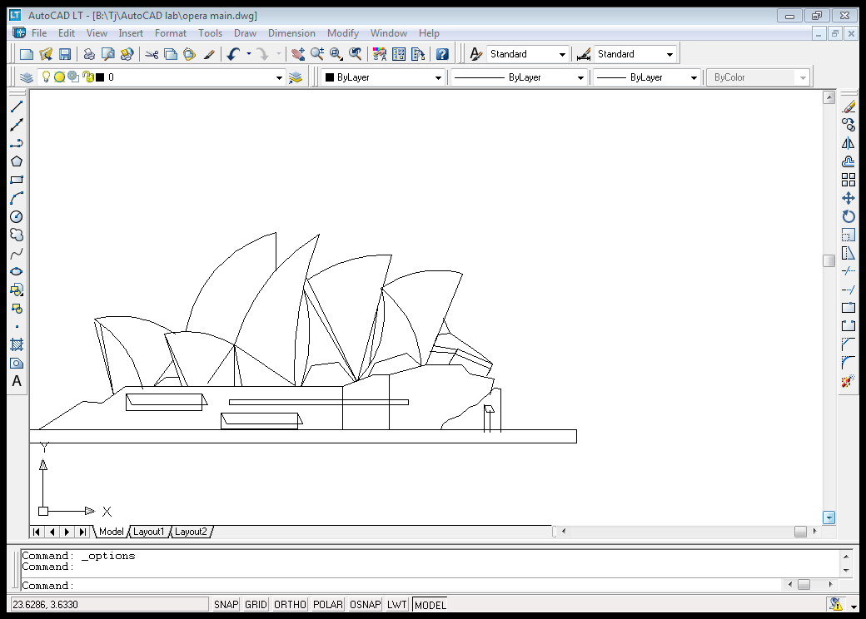Specify start point of arc or [Center]: 2.5669<268

Command: arc

Specify start point of arc or [Center]: 20,14.1188

Specify second point of arc or [Center/End]: @2.5669<268

Specify end point of arc: 18.9240,9.8616

Command: line

Specify first point:

Specify next point or [Undo]:

Command: arc

Specify start point of arc or [Center]: 20,14.1188

Specify second point of arc or [Center/End]: @2.8226<5

Command: arc

Specify start point of arc or [Center]: 20,14.1188

Specify second point of arc or [Center/End]: @2.8226<17

Specify end point of arc: 23.7608,14.7898

Command: line

Specify first point: 23.7608,14.7898

Specify next point or [Undo]: @4.5083<248

Command:

Command: arc

Specify start point of arc or [Center]: 20,14.1188

Specify second point of arc or [Center/End]: @1.9110<310

Specify end point of arc:

Specify end point of arc: 21.8461,10.5483188

Command: line

Specify first point: 21.8461,10.5483188

Specify next point or [Undo]: @0.8673<139

Command: line

Specify first point: 21.8461,10.5483188

Specify next point or [Undo]: @1.9110<310

LINE

Command: u

ARC

Command: redo

Command: line

Specify first point: 21.8461,10.5483188

Specify next point or [Undo]: @0.8673<139Specify next point or [Undo]: @1.5234<197

Specify next point or [Close/Undo]: @.7502<241

Command: arc

Specify start point of arc or [Center]: 15.75,16.75

Specify second point of arc or [Center/End]: 30.25,20.75

Specify end point of arc: 40,18.75

Command: offset

Specify offset distance or [Through] : .3

Select object to offset or <exit>:

Specify point on side to offset:

Command: arc

Specify start point of arc or [Center]: 20.25,14.75

Specify second point of arc or [Center/End]: 31.5,19

Specify end point of arc: 40,17.25

Command: offset

Specify offset distance or [Through] <0.3000>:

Select object to offset or <exit>:

Specify point on side to offset:

Command: line

Specify first point: 23.25,13.25

Specify next point or [Undo]: 40,13.25

Command: offset

Specify offset distance or [Through] <0.3000>:

Command: line

Specify first point: 31.5,20.5

Specify next point or [Undo]: <Osnap on><Snap on> @6.95<270

Command: offset

Specify offset distance or [Through] :1.5

Select object to offset or <exit>:

Specify point on side to offset:

Select object to offset or <exit>:

Specify point on side to offset:

Select object to offset or <exit>:

Specify point on side to offset:

Select object to offset or <exit>:

Specify point on side to offset:

Select object to offset or <exit>:

Command: trim

Current settings: Projection=UCS, Edge=None

Select cutting edges ...

Select objects: Specify opposite corner: 22 found

Select objects:

Select object to trim or shift-select to extend or [Project/Edge/Undo]:

Select object to trim or shift-select to extend or [Project/Edge/Undo]:

Select object to trim or shift-select to extend or [Project/Edge/Undo]:

Select object to trim or shift-select to extend or [Project/Edge/Undo]:

Command: line

Specify first point: 30,20.45

Specify next point or [Undo]: @2<316

Command: copy

Select objects: 1 found

Select objects: 1 found, 2 total

Select objects:

Specify snap spacing or [ON/OFF/Aspect/Rotate/Style/Type]:.3

Command: copy

Select objects: 1 found

Select objects: 1 found, 2 total

Specify base point or displacement, or [Multiple]: Specify second point of

displacement or <use first point as displacement>:

COPY

Select objects: 1 found

Select objects: 1 found, 2 total

Select objects:

Specify base point or displacement, or [Multiple]: snap

Specify base point or displacement, or [Multiple]: Specify second point of

displacement or <use first point as displacement>: @.3<180

Command:

COPY

Select objects: 1 found

Select objects: 1 found, 2 total

Select objects:

Command: offset

Specify offset distance or [Through]:.3

Select object to offset or <exit>:

Specify point on side to offset:

Command: line

Specify first point: 31.6,20.4

Specify next point or [Undo]: @1.988<315

Command: copy

Select objects: 1 found

Select objects: 1 found, 2 total

Select objects:

Specify base point or displacement, or [Multiple]: Specify second point of

displacement or <use first point as displacement>: @.3<180

Command: line

Specify first point: 33,20.2636

Specify next point or [Undo]: @1<317

Specify next point or [Undo]: u

Specify next point or [Undo]: @2<317

Command: copy

Select objects: 1 found

Select objects: 1 found, 2 total

Specify base point or displacement, or [Multiple]: Specify second point of

displacement or <use first point as displacement>: @.35<180

Command: line

Specify first point: 34.5,20

Specify next point or [Undo]: @2<317

Command: copy

Select objects: 1 found

Select objects: 1 found, 2 total

Select objects:

Specify base point or displacement, or [Multiple]: Specify second point of

displacement or <use first point as displacement>: @.3<180

Command: line

Specify first point: <Osnap on> 36,19.72

Specify next point or [Undo]: @2.129<315

Command: copy

Select objects: 1 found

Select objects: 1 found, 2 total

Select objects:

Specify base point or displacement, or [Multiple]: Specify second point of

displacement or <use first point as displacement>: @.3<180

Command: line

Specify first point:

Specify next point or [Undo]:

Command: copy

Select objects: 1 found

Select objects: 1 found, 2 total

Select objects:

Specify base point or displacement, or [Multiple]: Specify second

point of displacement or <use first point as displacement>:

Command: line

Specify first point: <Osnap on>

Command: line

Specify first point: 28.5,20.5

Specify next point or [Undo]: @2.2<313

Command: copy

Select objects: 1 found

Select objects: 1 found, 2 total

Select objects:

Specify base point or displacement, or [Multiple]: Specify second point of

displacement or <use first point as displacement>: @.3<180

Command: line

Specify first point: 27,20.3

Specify next point or [Undo]: @2.22<312

Specify next point or [Undo]: copy

Command: copy

Select objects: 1 found

Select objects: 1 found, 2 total

Select objects:

Specify base point or displacement, or [Multiple]: Specify second point of

displacement or <use first point as displacement>: @.3<180

Command: line

Specify first point: 25.5,20

Specify next point or [Undo]:

Specify next point or [Undo]: copy

Command: copy

Select objects: 1 found

Select objects: 1 found, 2 total

Select objects:

Specify base point or displacement, or [Multiple]: Specify second point of

displacement or <use first point as displacement>: @.3<180

Command: line

Specify first point:

Specify next point or [Undo]:

Command: copy

Select objects: 1 found

Select objects: 1 found, 2 total

Select objects: 1 found, 3 total

Select objects:

Specify base point or displacement, or [Multiple]: Specify second point of

displacement or <use first point as displacement>:

Command: line

Specify first point: 22.5,19.5

Specify next point or [Undo]:

Command: copy

Select objects: 1 found

Select objects: 1 found, 2 total

Select objects: 1 found, 3 total

Select objects:

Specify base point or displacement, or

[Multiple]: Specify second point of

displacement or <use first point as displacement>:

Command: line

Specify first point:

Specify next point or [Undo]:

Specify next point or [Undo]: copy

Point or option keyword required.

Command: copy

Select objects: 1 found

Select objects: 1 found, 2 total

Select objects: 1 found, 3 total

Select objects:

[Multiple]: Specify second point of

displacement or <use first point as displacement>: @.3<180

Command: bhatch

Select objects: 20 found

Specify first extension line origin or <select object>:

Specify second extension line origin:

Specify dimension line location or

[Mtext/Text/Angle]:

Command: dimlinear

Specify first extension line origin or <select object>:

Specify second extension line origin:

Specify dimension line location or

[Mtext/Text/Angle/Horizontal/Vertical/Rotated]:

Dimension text = 26.0000

Command: dimlinear

Specify first extension line origin or <select object>:

Specify second extension line origin:

Specify dimension line location or

[Mtext/Text/Angle/Horizontal/Vertical/Rotated]:

Dimension text = 10.0000

Command: dimradius

Select arc or circle:

Dimension text = 5.7450

Specify dimension line location or [Mtext/Text/Angle]:

Command: dimradius

Select arc or circle:

Dimension text = 4.6231

Specify dimension line location or [Mtext/Text/Angle]:

Command: dimradius

Select arc or circle:

Dimension text = 22.7150

Specify dimension line location or [Mtext/Text/Angle]:

Command: dimradius

Select arc or circle:

Dimension text = 8.7984

Specify dimension line location or [Mtext/Text/Angle]:

Command: plot

Press ESC or ENTER to exit, or right-click to display shortcut menu.

Effective plotting area: 134.17 wide by 286.87 high

Plotting viewport 2.

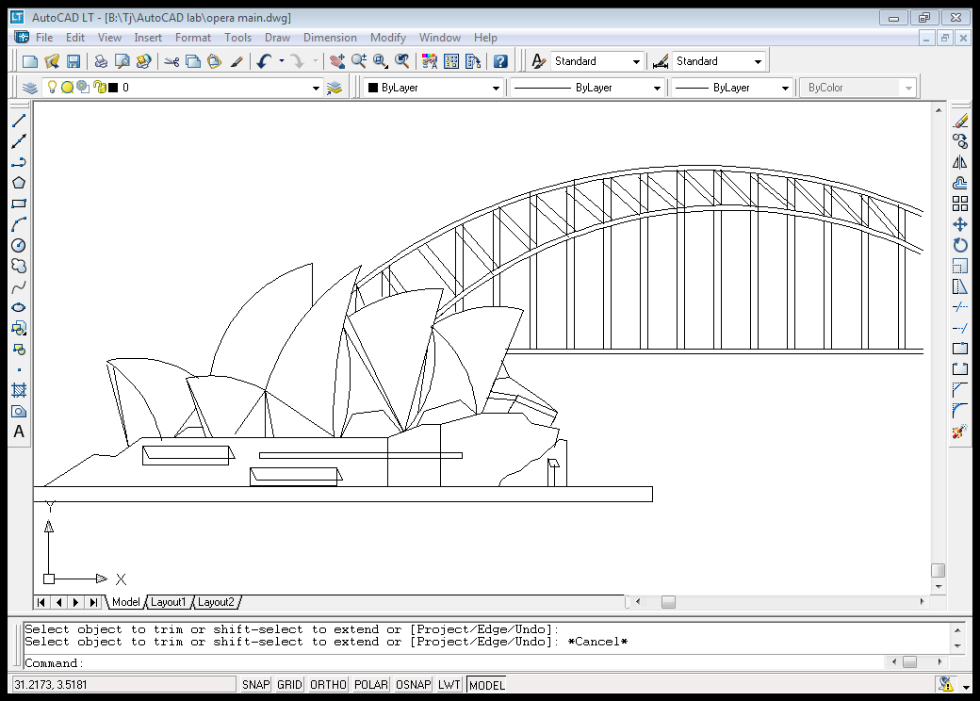

***CHAPTER # 07***

***CONCLUSION***

*In 1999, JørnUtzon was re-engaged as Sydney Opera House architect to develop a set of design principles to act as a guide for all future changes to the building. These principles reflect his original vision and help to ensure that the building’s architectural integrity is maintained.*In 2003 Utzon received the Pritzker Prize, international architecture's highest honour.